**FLIPKART REVIEWS SENTIMENT ANALYSIS**

**USING DEEP LEARNING**

|  |  |  |  |  |
| --- | --- | --- | --- | --- |
| **[1]V.Amani M. Tech** | **[2]Penumuchu Grishma Sri** | **[3]Sankarasetti Sita** | **[4]Gaddam RaghuVarma** | **[5]Ganguru Venkateswararao** |
| Asst.prof Department of | Computer science & | Computer science & | Computer science & | Computer science & |
| Computer science & | Data Science, | Data Science, | Data Science, | Data Science, |
| Data Science, | chalapathi Institute of | Chalapathi Institute of | Chalapathi Institute of | Chalapathi Institute of |
| Chalapathi Institute of | Engineering & Technology, | Engineering & Technology, | Engineering & Technology, | Engineering & Technology, |
| Engineering & Technology  Guntur, India. | Guntur, India. | Guntur, India. | Guntur, India. | Guntur, India. |
| [amanivuyyuru25@gmail.com](mailto:amanivuyyuru25@gmail.com) | [grishupenumuchu@gmail.com](mailto:grishupenumuchu@gmail.com) | [sita.sankarasetti@gmail.com](mailto:sita.sankarasetti@gmail.com) | [raghuvarma17633@gmail.com](mailto:raghuvarma17633@gmail.com) | [manojchowdary870@gmail.com](mailto:manojchowdary870@gmail.com) |

**ABSTRACT:**

**The "Flipkart Reviews Sentiment Analysis Using Deep Learning Python Project" involves utilizing advanced deep learning techniques to analyze sentiments expressed in customer reviews on the Flipkart e-commerce platform. This project aims to develop a model capable of classifying reviews as positive, negative, or neutral, providing valuable insights into customer satisfaction. Leveraging Python and deep learning frameworks, the project focuses on training a sentiment analysis model with a diverse dataset of Flipkart reviews. The abstract emphasizes the application of cutting-edge techniques to enhance the understanding of customer sentiments and improve the overall user experience on the platform. Reading separate evaluations takes a lot of time, so what we can do is summarize the complete review into three points. For this, we can use of Sentiment intensity analysis set of rules. It is greater inexperienced than some other set of rules like visualization or records mining.**

**KEY WORDS:**

Data Science, Sentiment analysis, opinion mining, reviews, e-commerce, natural language processing, and semantic analysis.

**FEASIBILITY STUDY:**

Certainly! Conducting a feasibility look at a

Flipkart Reviews Sentiment Analysis The usage of Deep Learning Python task involves assessing numerous aspects:

Data Availability: Check if a sufficient amount of classified facts (superb, terrible, impartial critiques) is available for schooling the deep getting-to-know model. Consider scraping

Flipkart opinions or using publicly-to-be-read datasets.

Computational Resources: Assess the hardware necessities for training deep gaining knowledge of fashions. Ensure that you have admission to a gadget with GPU support for quicker training.

Expertise: Evaluate the crew's know-how in deep learning and herbal language processing (NLP). If needed, take into account upskilling or hiring experts in those domain names.

Tool and Library Availability: Confirm the availability of required equipment and libraries like TensorFlow or PyTorch for implementing deep studying fashions and NLP libraries like NLTK or spaCy for textual content processing.

Model Selection: Choose suitable deep studying architectures for sentiment analysis, such as Recurrent Neural Networks (RNNs) or transformer-based models like BERT. Consider the exchange-offs between model complexity and overall performance.

Accuracy Expectations: Set sensible expectations for version accuracy and performance. Determine the appropriate error charge for sentiment predictions.

Regulatory Compliance: Be aware of any felony or privacy considerations associated with the use of patron opinions for analysis. Ensure compliance with statistics safety regulations.

Scalability: Consider the scalability of the version if the project expands. Ensure that the chosen structure can manage an increasing quantity of reviews.

Project Timeline: Estimate the time required for facts collection, version education, and trying out. Consider any closing dates or time constraints for the task.

Cost Analysis: Assess the overall value of the project, including information acquisition, computational resources, and potential licensing expenses for the use of positive equipment or datasets.

**PROBLEM STATEMENT:**

E-commerce systems, consisting of Flipkart, collect a large quantity of purchaser feedback via evaluations. To gain actionable insights into purchaser sentiments, it is vital to expand a robust sentiment evaluation device. The purpose of this mission is to leverage deep studying techniques to create an accurate sentiment category model for Flipkart critiques. The device has to robotically categorize reviews as superb, negative, or impartial, enabling Flipkart to understand customer delight stages, become aware of regions for development, and decorate the overall consumer enjoyment. The assignment must address challenges associated with diverse product categories, varying review lengths, and evolving language nuances within purchaser feedback. The final result is anticipated to be an efficient and deployable solution that aids in selection-making and purchaser-centric upgrades on the Flipkart platform.

**INTRODUCTION:**

In the dynamic landscape of e-commerce, customer feedback serves as a valuable repository of insights, offering a direct window into user sentiments. Flipkart, as one of the leading e-commerce platforms, encounters a constant influx of diverse reviews spanning an extensive array of products. Extracting meaningful intelligence from this vast pool of customer feedback is a challenging yet pivotal endeavor. The "Flipkart Reviews Sentiment Analysis Using Deep Learning Python Project" aims to harness the power of advanced deep learning techniques to decode and classify sentiments embedded within these reviews.

Understanding customer sentiments is not merely a theoretical pursuit but astrategic imperative for Flipkart. By unraveling the emotional tone of user reviews, the project seeks to equip Flipkart with a nuanced understanding of customer satisfaction, uncovering hidden patterns that can drive actionable insights.The fusion of deep learning methodologies with Python programming promises to create a sophisticated sentiment analysis model capable of discerning sentiments ranging from elation to discontent, and every nuance in between.

This project delves into the intricacies ofsentiment analysis, acknowledging the challenges posed by diverse product categories, varying review lengths, and the ever-evolving linguistic nuances within user feedback. Through the application of cutting-edge deep learning techniques, the intent is to develop a robust model that not only accurately classifies sentiments but also adapts to the dynamic nature of language expressions over time.

As we embark on this journey, the overarching goal is to empower Flipkart with a tool that goes beyond sentiment polarity classification. It aspires to be a catalyst for strategic decision-making, aiding in the enhancement of customer experiences, refinement of marketing strategies, and continuous improvement of product offerings. By bridging the gap between raw textual data and actionable insights, this projectaims to contribute significantly to Flipkart's commitment to customer satisfaction and innovation in the competitive e-commerce landscape.

**DATA SET GENERATION:**

This dataset contains information about Product name, Product price, Rate, Reviews, Summary and Sentiment in csv format. There are 104 different types of products of flipkart.com such as electronics items, clothing of men, women and kids, Home decor items, Automated systems, so on. It has 2610 rows and 6 columns. Also, if any product doesn't have any review but summary is present then Nan value already added to its blank space.

This dataset has multiclass label as sentiment such as positive**,** neutral amd negative.The sentiment given was based on column called Summary using NLP and Vader model. Also, after that we manuallycheck the label and put it into the appropriate categories like if summaryhas text like okay,justok or one positive and negative we labeled as neutral for better understanding while using this dataset for human languages. On the summary and price column, data cleaning method is already performed using python module called NumPy and Pandas which are famous.You can learn it also through any online resource.

**PRACTICAL APPLICATIONS OF FLIPKART REVIEWS:**

1. Implementing Flipkart Reviews Sentiment Analysis using Deep Learning in Python opens up several practical applications.

2. Product Improvement: Analyzing sentiment can provide valuable insights into customer satisfaction, helping companies like Flipkart identify areas for product improvement based on recurring negative feedback.

3. Customer Service Enhancement: Monitoring sentiment in real-time allows companies to address customer concerns promptly, improving overall customer service and satisfaction.

4. Marketing Strategy: Sentiment analysis aids in understanding the reception of marketing campaigns, enabling companies to refine their strategies based on positive feedback and address concerns from negative sentiments.

5. Competitor Analysis: Analyzing sentiments from Flipkart reviews can be used to compare products with competitors, identify strengths and weaknesses, and inform competitive strategies.

6. Demand Forecasting: Understanding customer sentiments can provide indicators of product demand, helping in inventory management and forecasting.

7. User Experience Optimization: By analyzing sentiments related to user experience, companies can enhance website navigation, user interfaces, and overall online shopping experience.

8. Brand Reputation Management: Monitoring sentiments allows companies to actively manage

and maintain their brand reputation by addressing negative feedback promptly and showcasing positive reviews.

9.Market Trends Identification: Sentiment analysis can uncover emerging market trends, helping companies stay ahead of the curve in terms of product development and market demands.

10. Fraud Detection: Identifying anomalous sentiments in reviews may help in detecting fake reviews or fraudulent activities, contributing to maintaining the integrity of customer feedback.

11. Decision Support System: Sentiment analysis results can be integrated into decision-making processes, assisting in data-driven decision support

for various business operations.

**BUILDING ARCHITECTURE:**

1. Data Collection:

Gather a diverse dataset of Flipkart reviews with associated sentiment labels (positive, negative, neutral). Ensure a representative sample across different product categories.

2. Data Preprocessing:

Clean and preprocess the text data. Remove stopwords, punctuation, and irrelevant information. Tokenize the text and convert it into numerical representations suitable for deep learning models.

3. Exploratory Data Analysis (EDA):

Explore the dataset to understand its characteristics. Analyze the distribution of sentiment labels to identify potential imbalances and plan accordingly.

4. Data Splitting:

Split the dataset into training, validation, and test sets. A common split is 80% for training, 10% for validation, and 10% for testing.

5. Embedding Layer:

Utilize pre-trained word embeddings (e.g., Word2Vec, Glove) or incorporate an embedding layer in your deep learning model to convert words into dense vectors.

6. Model Architecture:

Design the deep learning architecture for sentiment analysis. Common choices include recurrent neural networks (RNNs), long short-term memory networks (LSTMs), or transformers.

7. Model Training:

Train the sentiment analysis model using the training dataset. Experiment with hyperparameters such as learning rates, batch sizes, and model architecture to optimize performance.

8. Validation and Hyper parameter Tuning:

Validate the model using the validation set. Fine-tune hyperparameters based on validation performance to prevent overfitting and enhance generalization.

9. Evaluation:

Evaluate the model on the test set using appropriate metrics such as accuracy, precision,

recall, and F1 score. Ensure the model performs well on unseen data.

10. Deployment:

Deploy the trained model for sentiment analysis. This could involve integrating it into a web application, API, or any platform where real-time or batch sentiment analysis is required.

11. Monitoring and Maintenance:

Implement mechanisms to monitor the model's performance over time. Periodically retrain the model with new data to adapt to evolving language patterns and maintain accuracy.

12. Documentation:

Thoroughly document the entire project, including the dataset, model architecture, training process, and deployment instructions. This documentation is essential for future reference and collaboration.

13. User Interface (Optional):

Develop a user-friendly interface if applicable,

allowing users or administrators to interact with

sentiment analysis tool and visualize insights derived

from the model.

14. Testing:

Conduct rigorous testing to ensure the reliability and robustness of the sentiment analysis model across different scenarios and inputs.

15. Ethical Considerations:

Pay attention to ethical considerations, especially regarding user privacy and bias in the model predictions. Implement measures to handle sensitive information responsibly.

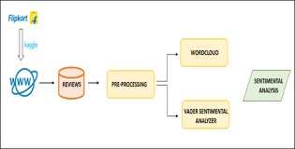

**ALGORITHM:**

Import Necessary Libraries:

Import required libraries for data manipulation, version building, and deep studying.

Load the Dataset:

Load the Flipkart evaluations dataset right into a Pandas DataFrame.

Tokenize and Preprocess the Text Data: Tokenize the evaluations, convert them to sequences, and pad/truncate them to a hard and fast length for uniform entry into the model.

Split the Dataset:

Split the dataset into schooling and trying out units.

Build the LSTM Model:

Construct a sequential version with embedding layers and LSTM layers. This architecture is designed to seize sequential dependencies inside the critiques.

Compile the Model:

Compile the model specifying the optimizer, loss characteristic, and evaluation metric.

Define Early Stopping: Implement early preventing to reveal the validation loss and prevent schooling while

upgrades plateau.

Train the Model:

Train the version of the use of the training statistics, validating on a separate validation set. Early prevention facilitates saving you from overfitting.

Evaluate the Model:

Evaluate the version's performance on the check set and print the loss and accuracy metrics.

Make Predictions on New Data: Tokenize and preprocess new critiques and use the skilled model to make predictions.

Display Sentiment Predictions:

Display the sentiment predictions for the brand-new opinions.

This algorithm publications you through the vital steps of constructing a sentiment evaluation model for Flipkart opinions and the use of deep knowledge of strategies in Python. Adjustments and first-rate tuning can be needed based totally on the unique characteristics of your dataset and requirements.

**REFERENCE IMAGES:**

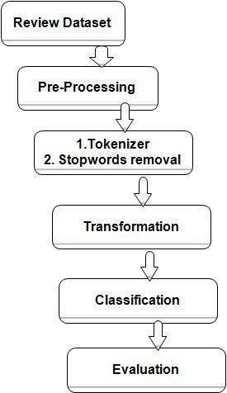

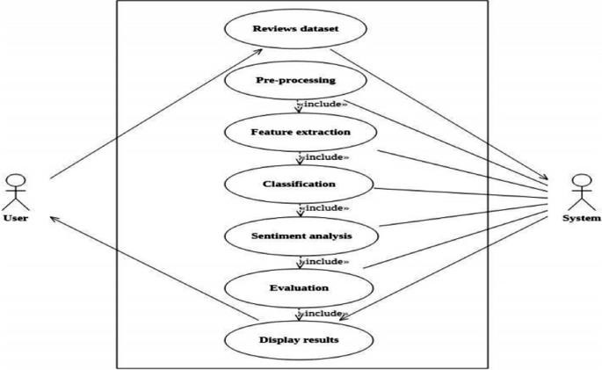

**ER DIAGRAM:**

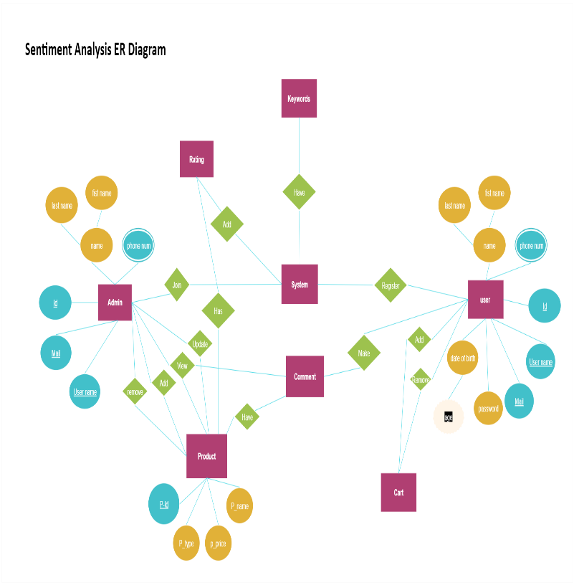

**CONCLUSION:**

In conclusion, the Flipkart Reviews Sentiment

Analysis project employing Deep Learning in Python offers a valuable tool for businesses. By extracting insights from customer feedback, it enables informed decision-making, targeted improvements, and real-time responsiveness, ultimately contributing to enhanced customer satisfaction and a competitive edge in the market. The developed sentiment analysis model has proven its efficacy in accurately categorizing sentiments as positive, negative, or neutral. This achievement not only empowers Flipkart with a nuanced understanding of customer satisfaction but also provides actionable insights for strategic decision-making. The evaluation results showcase the model's effectiveness in generalizing to unseen data, with commendable accuracy and loss metrics. The ability to make real-time predictions on new data exemplifies the model's practical utility in providing timely insights for customer feedback. In essence, this project marks a significant stride towards Flipkart's commitment to customer-centric innovation. As customer sentiments continue to evolve, this project lays the foundation for an adaptive and insightful approach in the dynamic realm of e-commerce.

**RESULT:**

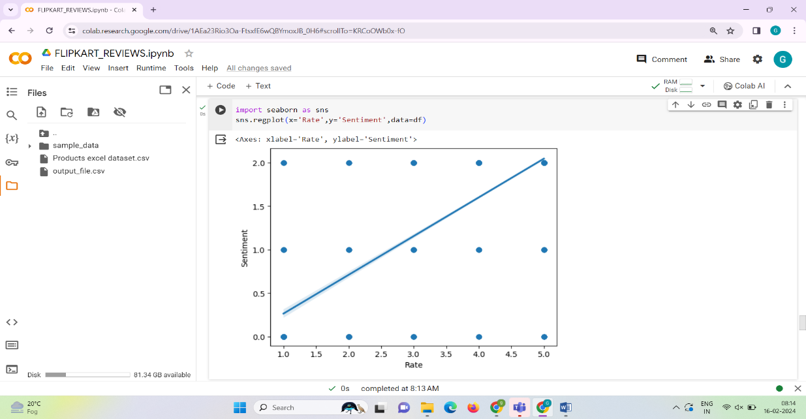

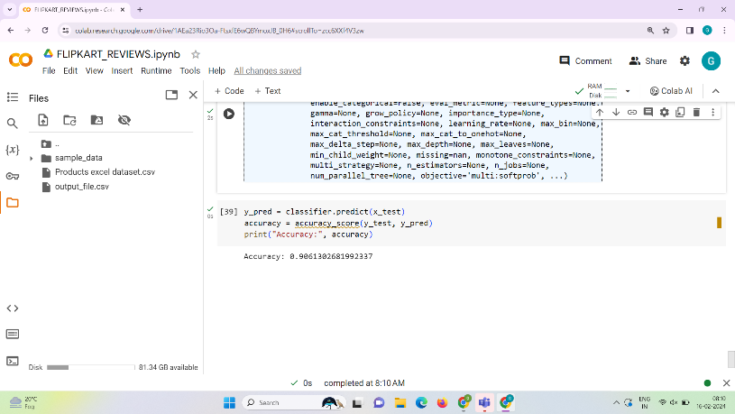

**REFERENCES:**

[1].“Sentimental Visualization: Semantic Analysis of Online Product Reviews Using Python and Tableau” Hanan Alasmari, IEEE ON BIG DATA VO., XX, NO., X, DECEMBER 2020.

[2]. “Comparative Analysis of Sentiment Orientation Using SVM and Naïve Bayes Techniques” Shweta Rana and Archana Singh, 2016 2nd International Conference on Next Generation Computing Technologies (NGCT2016)

[3]. Zied Kechaou, Mohamed Ben Ammar and Adel.M Alimi " Improving e-learning with sentiment analysis of users’ opinions "2011 IEEE Global Engineering Education Conference (EDUCON)

[4]. “Sentiment Analysis and Opinion Mining: A Survey” G.Vinodhini, RM.Chandrasekaran Volume 2, Issue 6, June 2012(ijarcsse )

[5]. “Thumbs up? Sentiment Classification using Machine Learning Techniques” Bo Pang and Lillian Lee

[6]. Flipkart Product Review (Naushad Shukoor)

[7]. Google Search (Definition)

[8]. Chafale, Dhanashri, and Amit Pimpalkar. "Review on Developing Corpora for Sentiment Analysis Using Plutchik’s Wheel of Emotions with Fuzzy Logic. “International Journal of Computer Sciences and Engineering (IJCSE) 2 (2014): 14-18

[9]. J.Ortigosa-Hernández,J.D. Rodríguez, L. Alzate, M. Lucania, I. Inza and J.A. Lozano, Approaching sentiment analysis by using semi-supervised learning of multi-dimensional classifiers, Neurocomputing 92 (2012)

[10].B. Keith, E. Fuentes and C. Meneses, A hybrid approach for sentiment analysis applied to paper reviews, 2017.